Traffic Simulating System
Software Architecture Document

Version 2.0

Revision History
Date | Version | Description | Author
24/Nov/2008 | 1.0 | Draft of SAD | Mohan Yang
05/Jan/2009 | 2.0 | Final Version | Mohan Yang
13/Jan/2009 | 2.1 | Modified Version | Liangda Li

Table of Contents
1. Introduction 4
1.1 Purpose 4
1.2 Scope 4
1.3 Definitions, Acronyms, and Abbreviations 4
1.4 References 4
2. Architectural Representation 4
3. Architectural Goals and Constraints 4
4. Use-Case View 5
4.1 Architecturally-Significant Use Cases 5
4.2 Use-Case Realizations 5
4.2.1 Load Map 5
4.2.2 Add Vehicle 8
4.2.3 Simulating 11
4.2.4 View Result 13
5. Logical View 15
5.1 Overview 15
5.2 Architecturally Significant Design Packages 15

Software Architecture Document

Introduction

Purpose
This document provides a comprehensive architectural overview of the system, using a number of different architectural views to depict different aspects of the system. It is intended to capture and convey the significant architectural decisions which have been made on the system.

Scope
This Software Architecture Document provides an architectural overview of the Traffic Simulating System. The Traffic Simulating System is being developed by SJTU 06ACM Honored working group.

Definitions, Acronyms, and Abbreviations
See the Glossary [2].

References
Applicable references are:
- Vision, V2.0, 04/Jan/2009, SJTU 06ACM Honored Class.
- Glossary, V1.0, 05/OCT/2008, SJTU 06ACM Honored Class.
- Use-Case Specification: Load map, V2.0, 05/Jan/2009, SJTU 06ACM Honored Class.
- Use-Case Specification: View Statistic, V1.0, 05/OCT/2008, SJTU 06ACM Honored Class.
- Use-Case Specification: Car Simulating, V3.0, 04/Jan/2009, SJTU 06ACM Honored Class.
- Use-Case Specification: Add vehicle, V1.0, 05/OCT/2008, SJTU 06ACM Honored Class.
- Software Requirements Specification, V2.0, 08/Jan/2009, SJTU 06ACM Honored Class.
- Supplementary Specification, V1.1, 01/Jan/2009, SJTU 06ACM Honored Class.

Architectural Representation
This document presents the architecture as a series of views; use case view, logical view, process view and deployment view. There is no separate implementation view described in this document. These are views on an underlying Unified Modeling Language (UML) model developed using PowerDesigner.

Architectural Goals and Constraints
There are some key requirements and system constraints that have a significant bearing on the architecture. They are:
- The existing external road information system must be interfaced with to support loading map information and creating map from real world.
- The existing external vehicle information system must also be interfaced with to support loading vehicle information and creating specified vehicle.
- All performance and loading requirements, as stipulated in the Vision Document [1] and the Supplementary Specification [8], must be taken into consideration as the architecture is being developed.

Use-Case View

Architecturally-Significant Use Cases
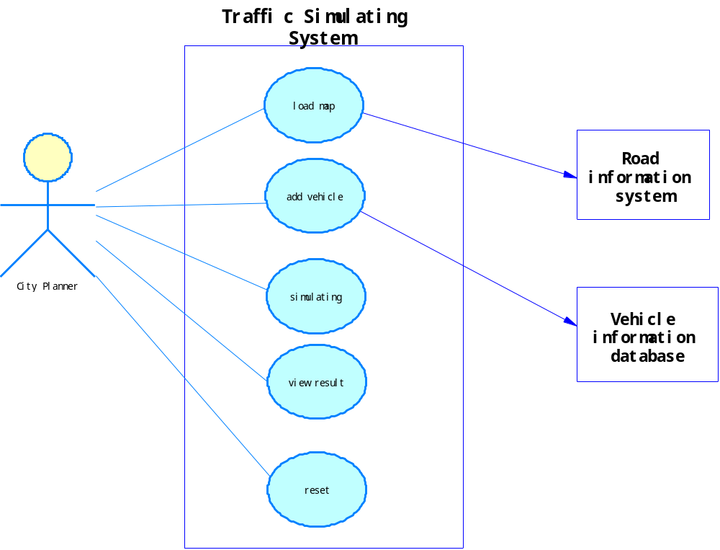

Use-Case Realizations

Load Map
Brief Description: This use case allows a city planner to load a road map from road information system. The road information system will provide the data through an xml file and the traffic simulating system read the file and shows the correspondent map to the city planner.
The class diagram of this use case is as follows.
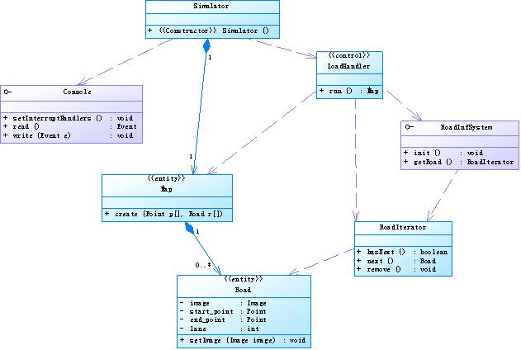
The sequence diagram of this use case is as follows.
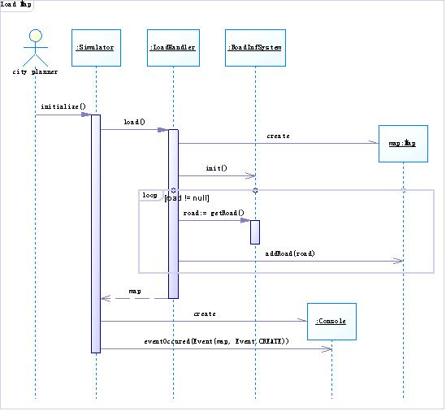
The iterator pattern is used in the implementation of the external road information system.
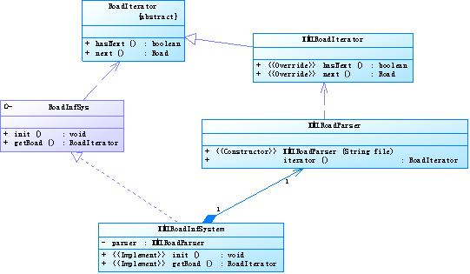
In the initialization of the graphic panel, the template method pattern is used.
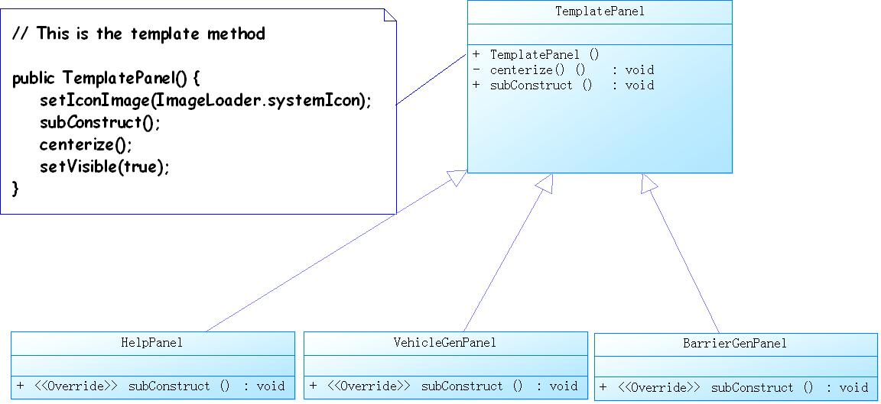

Add Vehicle
Brief Description: This user case add vehicle to system to complete the traffic simulating process. User can choose different types of vehicle and put it on a given point of the map to start moving. The backstage controller handles the request and performs the operation.
The class diagram of this use case is as follows.
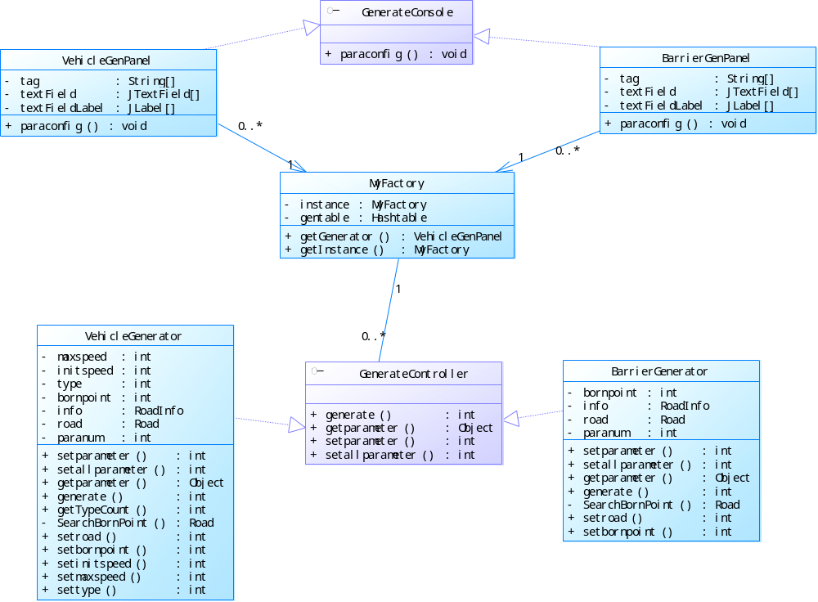

The sequence diagram of this use case is as follows.
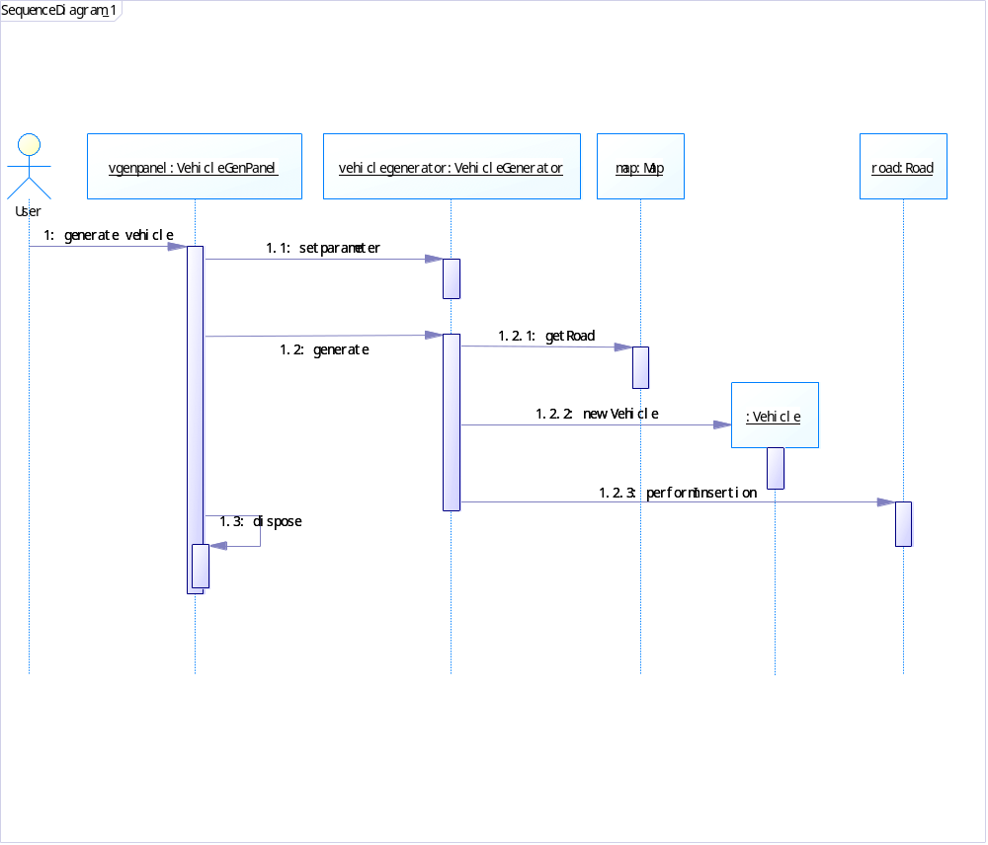

The adapter pattern is used for adding different object on the map in the traffic simulation system.
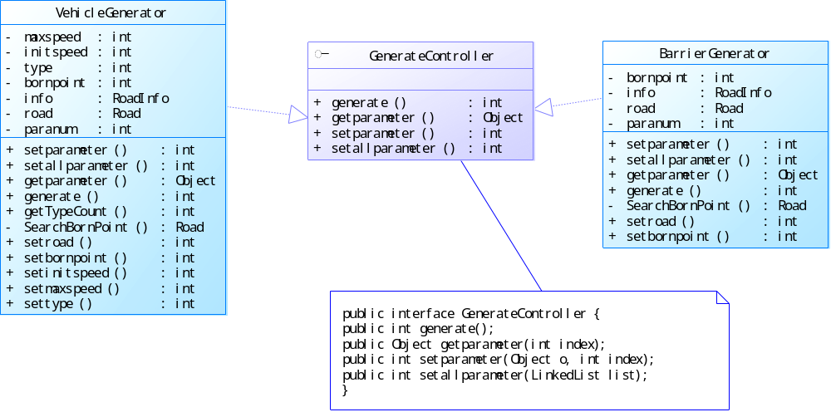

For the construction of those generator, we employ Factory pattern and Singleton pattern as follows.
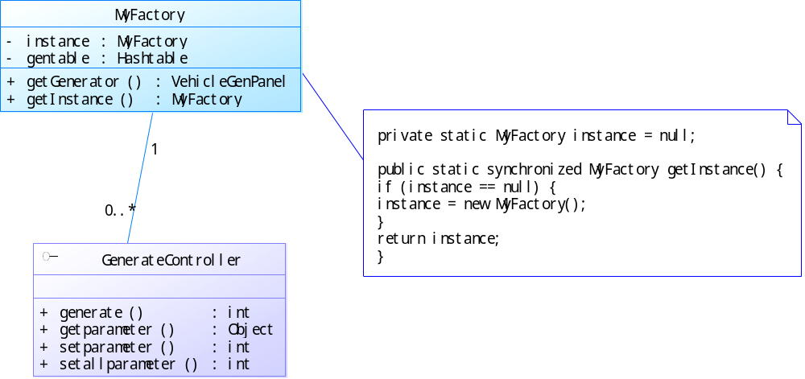

Simulating
Brief Description: This use case simulates the actions of a car after it is created in previous processes. It handles the motion of the car, how it reacts to different situations of the road, change its lane, turn into different roads, accelerate or slow down, and all kinds of other actions.
The class diagram of this use case is as follows.
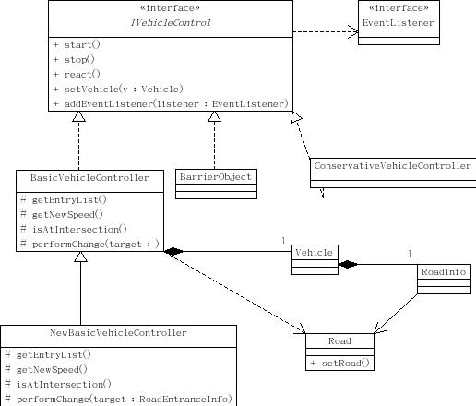
The sequence diagram of this use case is as follows.
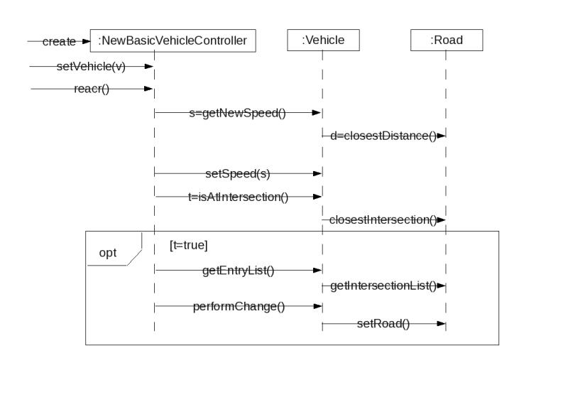
Strategy pattern is used in the implementation of different vehicle control algorithms. As for the vehicle control algorithm, template method pattern is used with a skeleton of the following three functions.
- Check closest Vehicle
- Check nearest intersection
- Decide whether make turns

View Result
Brief Description: This use case allows a City Planner to view the statistics from the simulating system.
The class diagram of this use case is as follows.
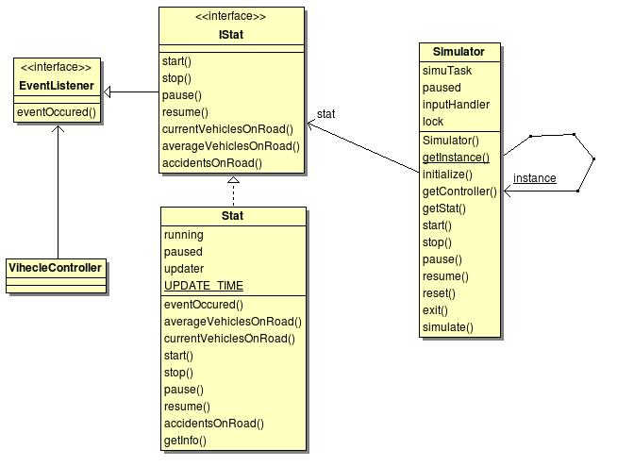
The sequence diagram of this use case is as follows.
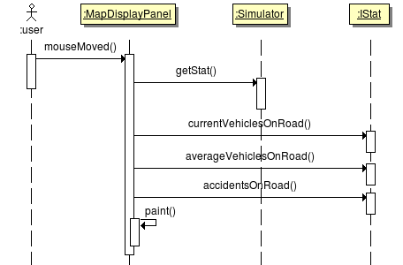
Strategy pattern is used in this use case to allow different implementations of statistics. Observer pattern is used to collect information from vehicle.

Logical View

Overview
We use three layer structures which are the UI layer, the domain layer and the entity & data layer.
- The UI layer handles with output task such as console output or graphic user interface view.
- The domain layer handles with simulating task which is the kernel and the main part of the system.
- The entity & data layer handles with real data definition and convert the data from external system into the internal format needed.

Architecturally Significant Design Packages
